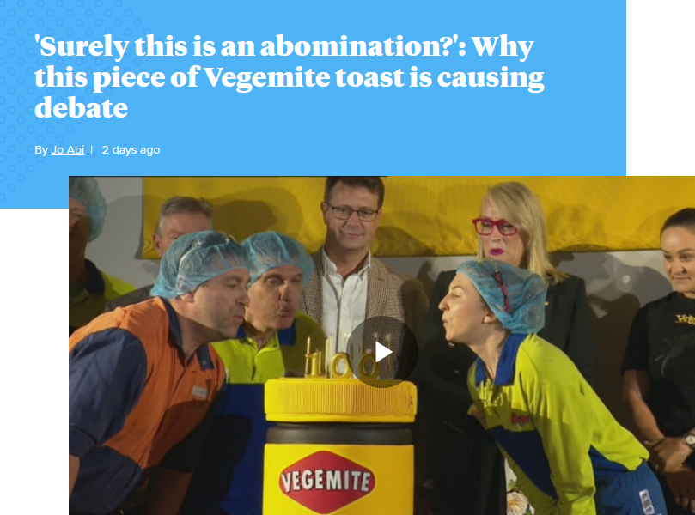

A﻿ piece of Vegemite toast is causing debate this morning because it seems there is a 'right' and a 'wrong' way to spread the Aussie favourite.

At least that is according to one husband who is so shocked by how his wife has spread Vegemite on her toast that he has shared a photo of it on Reddit

"How my wife 'spreads' Vegemite," he captioned the image, adding: "Whether you like Vegemite or not, surely this is an abomination?"

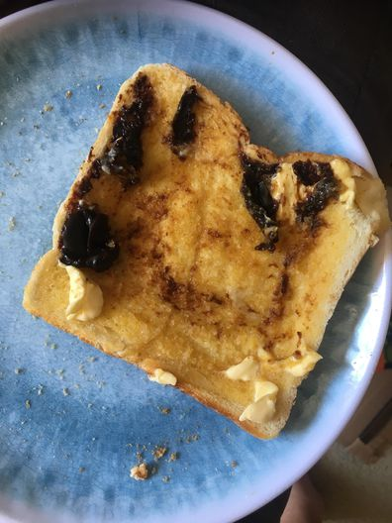
In the photo we see a rather soggy piece of toast on a plate, with melted butter all over it.

Somehow, majority of the butter is ﻿melted into the toast, but there are still some globs of it clinging to life aside chunks of Vegemite.

What's most confusing is that there seems to be no correlation between the positioning of the globs of butter and Vegemite, with the unmelted butter on the bottom of the toast and majority of the Vegemite up the top.
'How my wife 'spreads' Vegemite.' (Reddit)
'Whether you like Vegemite or not, surely this is an abomination?'
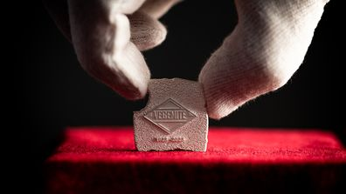
The tiny toast that holds a huge piece of Australian history
View Gallery

"I'm sorry about your pending divorce," one Redditer commented.
"Don't be. It's clearly the right decision," another said.
"The police have been informed," another joked, with one Redditer labelling it a "red flag."
Another added: "People have had their citizenship revoked for less than that."
Other Redditers were simply confused about not just how the Vegemite has been spread, but the multiple other "toast offences" highlighted in this photo.

"People have had their citizenship revoked for less than that."

"Is the problem that the toast isn't toasted enough to spread the vegemite without gouging the…soft toaster-warmed bread?" one commented.
Then there was this controversial suggestion: "This is why I put the Vegemite on first and then the butter. It avoids the tearing of the toast."
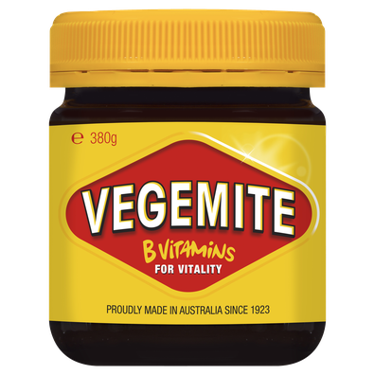
'This is why I put the Vegemite on first and then the butter. It avoids the tearing of the toast.' (Supplied)

Although some didn't see a problem with his wife's creation.
"I don't see the problem. Some parts are salty savoury paradise and then you chase it with buttery goodness," one Redditer said.

