By Lee Tran Lam
7th April 2023
Vegemite started out as a response to a wartime shortage of Marmite. It’s now a symbol of Australia that’s spread onto toast, added to curries and even churned into ice-cream.
Vegemite has inspired national pride – and outrage – since its invention a century ago in Melbourne. The salty spread was once so popular that it was found in nine out of 10 Aussie homes, but its polarising taste has landed it in the Disgusting Food Museum in Sweden, too.
The punchy condiment has the dark gloss of a vinyl record, and the intense tang of its boozy power source (brewer's yeast) generates reactions that are as strong as its flavour. American TV host Jimmy Fallon and announcer Steve Higgins comically squirmed after trying it on Fallon's late-night TV show seven years ago – prompting Australian actor Hugh Jackman to school them on Vegemite appreciation (a common mistake is to ferociously slather on the condiment like it's Nutella; Jackman proudly demonstrated how Vegemite should be lightly smeared onto buttered toast, using "the crappiest bread possible").
And when Tom Hanks swiped a far-too-thick layer onto toast while quarantining in Australia in March 2020, it became a worldwide scandal that made news in South Africa, Cambodia and India.
These passionate reactions on how to properly consume Vegemite signifies how culturally important the yeasty spread has become since first hitting grocery shelves on 25 October 1923, several months after its invention. Vegemite's centenary is such a momentous milestone that the Royal Australian Mint has even issued a special coin featuring the iconic sight of Vegemite on toast – minus a hungry bite.
ADVERTISEMENT
The intensely flavoured condiment is so strongly linked to Australian identity that international culinary figures – Nigella Lawson and René Redzepi among them – are driven to cook with Vegemite while visiting the country, and local chefs draw on the flavour in multicultural dishes. But Vegemite was "an epic fail" when first introduced a century ago and its inventor Cyril Callister isn't a household name – even his relatives barely realised his achievements.
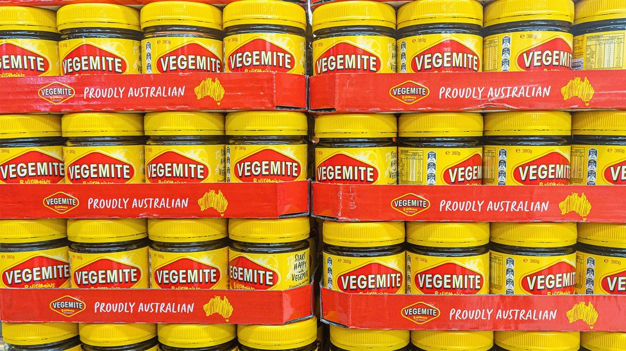
Vegemite was invented a century ago in Melbourne by Cyril Callister (Credit: amer ghazzal/Alamy)
Jamie Callister was six years old when he learnt about his grandfather Cyril's claim to fame. "Put it in this way, it wasn't an introductory line when I met people," said the author of Vegemite: The true story of the man who invented an Australian icon. "The few times I did try it at school, people would take the piss out of me and say, 'my grandfather invented peanut butter'."
When Jamie started researching the life of Vegemite's creator, he was surprised by what he learned. "What I found was remarkable," he said. His grandfather's story had dramatic backdrops (like the munitions factory where Cyril met Sherlock Holmes creator Arthur Conan Doyle), underdog scenarios (as a scholarship student, he attended school with Robert Menzies, Australia's longest-serving prime minister) and highlighted Cyril's star talent (he was a "brilliant scientist … at the top of his field," said Jamie). Cyril was innovative in many areas, from food dehydration to food nutrition, and his cheese-processing expertise even impressed American brand Kraft.
Cyril invented Vegemite in 1923, after Melbourne's Fred Walker & Co hired him to create a local alternative to Marmite, a popular yeast spread from the UK. The potential for Cyril's creation was huge: attacks from German U-boat fleets had disrupted Australian supplies of Marmite during World War I, and shortages of imported foods continued after the war ended. Producing a reliable, Australian version of the salty British condiment could prove hugely lucrative. The reality? "In its infancy, Vegemite was going nowhere," Jamie said. "The head salesman, he couldn't stand the smell, let alone the taste… there were more jars coming back to the factory than going out."
In a desperate act, Fred Walker & Co changed Vegemite's name to Parwill. It was a "corny play on words", said Jamie (think "Ma might, Pa will"). It didn't last.
Two breakthroughs turned the condiment's fortunes around. Robert Plimmer from the University of London's St Thomas Medical School declared Vegemite a nutritional powerhouse – a discovery he made after feeding Vegemite to his ailing pigeons (at his poultry farm) for a month. When his pigeons recovered from polyneuritis, a nerve disorder caused from a vitamin B1 deficiency, it was clear the yeast extract was rich in nutrients, particularly vitamin B. Also, Vegemite finally took off when they literally gave it away with blocks of cheese.
Jamie's book, originally released as The man who invented Vegemite: the true story behind an Australian icon in 2012, has been updated to commemorate Vegemite's 100th birthday. It features a new ending, thanks to Vegemite returning to Australian ownership after local dairy company Bega bought it from American food giant Mondelez in 2017.
Liza Robinson offers a different angle on Vegemite's creator – via the Cyril Callister pop-up museum she's running in Beaufort, a town 160km west of Melbourne. When she moved here in 2014, her partner Dr Ian Beasley showed her a photo of his family in the nearby town of Chute. "They stood around a sign that said, 'The man who invented Vegemite was born here'," she said. "The man who invented Vegemite is my grandfather!" he told her. He was related to Jamie, too.

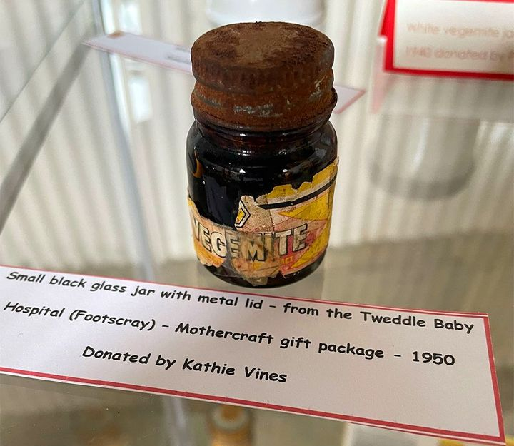
The Cyril Callister pop-up museum currently features Vegemite memorabilia
(Credit: Cyril Callister pop-up museum)

She thought this Australian icon deserved more than a sign in a small town, so Robinson started the museum last year. In May, she's moving it to a permanent retail location on the main drag. The museum currently features Vegemite memorabilia such as 50-year-old posters, condiment jars from the 1940s and World War Two ration tins. (During the war, locals gave up their supply so soldiers could carry tins of Vegemite in their ration packs.)
"Yesterday, I had a group of seven nurses from [nearby] Ballarat, who did their nurse training 60 years ago," she said. They were fascinated by a Vegemite jar that was given to new mothers at Footscray's Tweddle baby hospital in the 1950s for nutritional reasons.
The museum also features many branded items to buy, from tea towels to dog bandanas. "Everything that's got Vegemite on it, we sell," Robinson said. All revenue will one day help provide scholarships for regional youth to study in the area, an opportunity Cyril's cash-strapped family benefited from. She also believes the museum will become a much-needed tourist attraction once an upcoming highway bypasses Beaufort entirely.
Vegemite's influence is felt far beyond Cyril's local origins, too.

Wherever I am in the world, it has to be in my pantry.
"Wherever I am in the world, it has to be in my pantry," Australian cookbook author Hetty Lui McKinnon said of the salty spread. She was unpersuaded by the "sweet and gloopy" Marmite her English workmates ate when she lived in London. "I knew that they snuck some of my Vegemite when I wasn't looking, because my jar never seemed to last!"
After putting a buttery miso Vegemite noodle recipe in her To Asia, With Love cookbook, the Brooklyn-based author learned she'd converted other sceptics. This multicultural use of the condiment reflects a wider trend, where chefs will remix Vegemite in various cuisines, from Mexican (Maïz restaurant offers a mole-like version in Sydney) to Malaysian (Sydney's Ho Jiak serves Vegemite ribs at its Haymarket outpost).
"For many immigrants, Vegemite is seen as the quintessential 'Australian food', so combining Vegemite with foods of their own cultural cuisines is a way to bring two worlds together," said Lui McKinnon. Her Chinese cousin stirring ultra-savoury Vegemite through plain congee is "a genius recipe", for example.
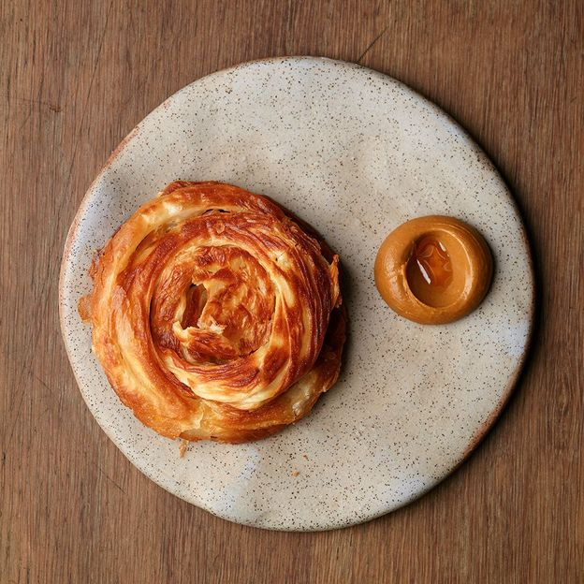
Roti with Vegemite curry (Credit: Sunda 22)
Khanh Nguyen's roti with Vegemite curry at Melbourne's Sunda has been named "one of the city's must-try snacks" and has been on the menu since the restaurant's opening in 2018 – the chef has sold 20,000 serves of this boldly flavoured dish. The well-spiced, tamarind-sour curry is thick in consistency and more like a taramasalata dip. "The secret ingredient is sour cream," Nguyen said. "That just softens the blow of the saltiness a bit."
Nguyen remembers the first Vegemite sandwich he had at age six – its punchy taste reminiscent of the strong Vietnamese flavours he grew up with, such as shrimp paste. He also worked at Noma's Sydney pop-up in 2016 when it presented its version of the classic condiment with an abalone schnitzel, plated with Australian bush foods.
This trend of using Vegemite beyond its white-bread default is something Australian restaurant critic Dani Valent has noticed. She's written about chef Shirley Summakwan's surprise use of the rich spread in a Hainanese chicken club sandwich at Moonhouse, a Chinese restaurant in Melbourne. "Pretty much every chef I'd interview that's from a non-Anglo cultural background of a certain age would talk about how the other kids at school had Vegemite sandwiches," Valent said. "Definitely a lot of people encountered and feel like they had to grapple with it only because they weren't eating it."
She also recalls when British chef Ashley Palmer-Watts went through 10kg of Vegemite while trying to understand the ingredient at the Melbourne outpost of London's Dinner By Heston (which ran from 2015 to 2020). "It's so interesting that it's so mainstream, yet such a mystery and conundrum to an accomplished chef like Ashley Palmer-Watts. Australians would perhaps feel quite proud of that," she said. He eventually settled on a Vegemite ice-cream for the menu.
Valent also remembers when Nigella Lawson presented a Vegemite spaghetti at the 2011 edition of Melbourne Food and Wine Festival. "There was a mixture of alarm that there was something so lowbrow being used by this kitchen goddess, but I think there was also a real pride that someone with such an international profile and appeal was grappling with something that was in every Australian pantry."
Nowadays, there are no limits to how Vegemite is used. The official Vegemite cookbook features Vegemite raspberry brownies, while everything from Vegemite cannoli to Vegemite roast chicken has been sold in Australia.
This far-ranging interest in the condiment might symbolise how widely Australians embrace Vegemite – regardless of their background. It's something that Jamie Callister agrees with. "It's not just my story, I feel like it's our story," he said. "We've all got ownership of Vegemite in some way, it's who we are. It's in our DNA."
Recipe: Buttery miso Vegemite noodles
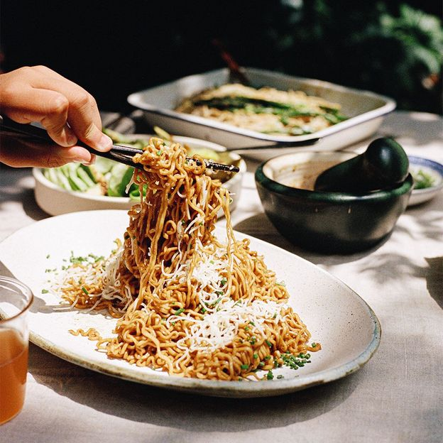
Buttery miso Vegemite noodles (Credit: Hetty Lui McKinnon)

